Program Design

1. **Base**

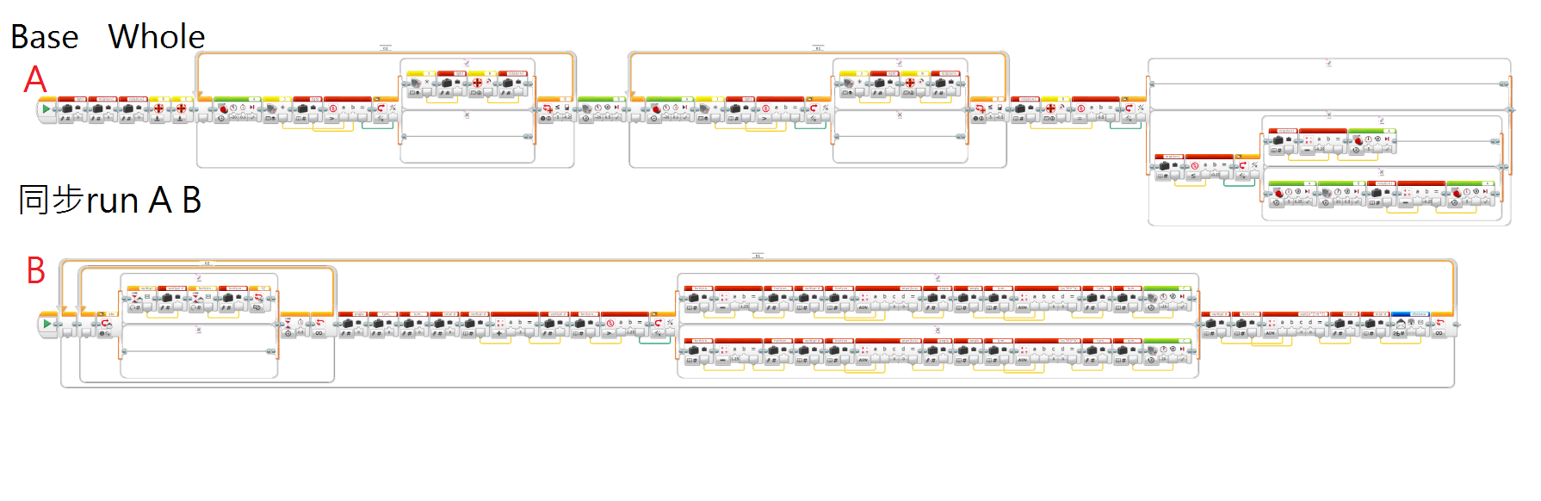

**^The above graph is the whole program of Base**

Program Interpretation: This program control the receive the signal from the prospector.(detail in the part of prospector) and calculating angle data in order to adjust the initial departure angle of the collector.

**Magnified graph:**

**Left part of the whole program**

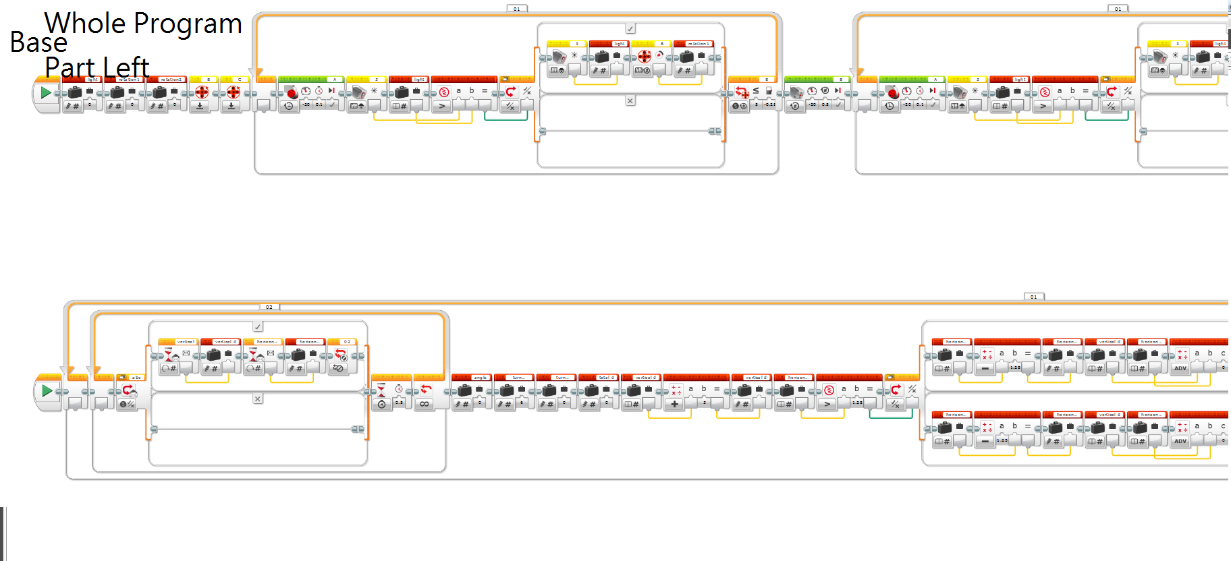

**Right part of the whole program**

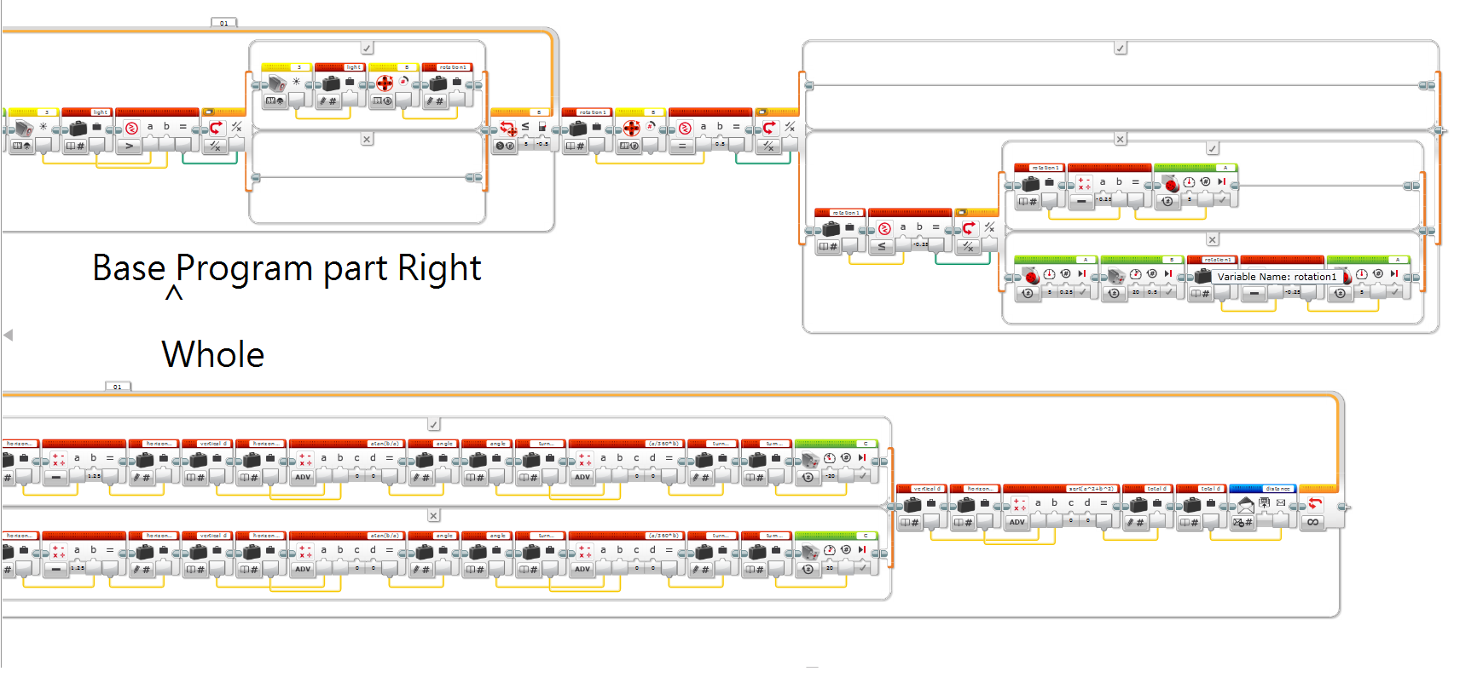

1. **Prospector**

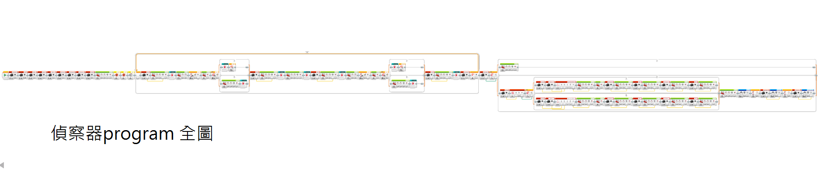

**^ The above graph is the whole program of the Prospector, with two block builder inside.**

Program Interpretation : This program control the prospector, when prospector go outside the planet surface, it will run as “Z” shape and prospect whether there is any energy source. Prospector will stop and back to the base when it sense energy source. Also prospector will save the data of the rotation of the two motor of the prospector in order to calculate the path difference so that prospector can back to the base successfully.

1. No matter the energy sources are place on any where of the prospector’s run path, after the calculation of the rotation, prospector can back to the base .
2. Using the trigonometric calculation so as to calculate the displacement from the adjustment point in base to energy source, after that , the result of displacement will be sent to the base and for the further calculation.

Program feature :

Automatic Positioning ------------- as the first bullet point above shown, prospector will save the data of the rotation that has been run during the process of prospecting the energy source. When prospector sense the energy source, prospector will call the data and calculate the path different in order to run back to the base. As a result, no matter where the energy sources are placed, prospector can position itself back to the base.

Calculation of displacement ----------- As the second bullet point above shown, Prospector will use trigonometric calculation to calculate the rotation data recorded during the running of prospector and turn the data in to a displacement data, further , prospector will send the displacement data to the base.

**Magnified graph:**

**Left part of the whole program**

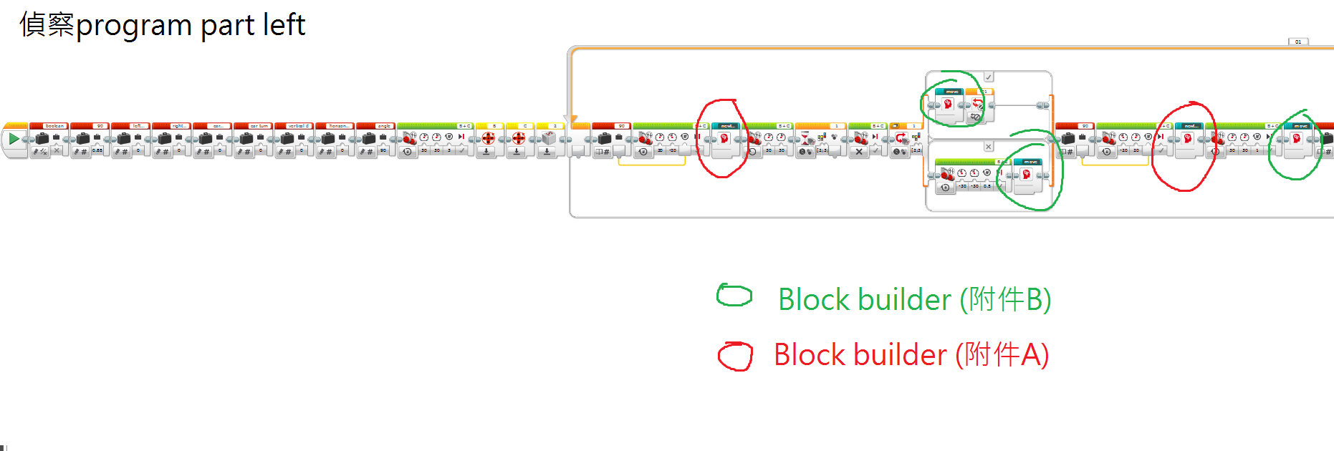

**Middle part of the whole program**

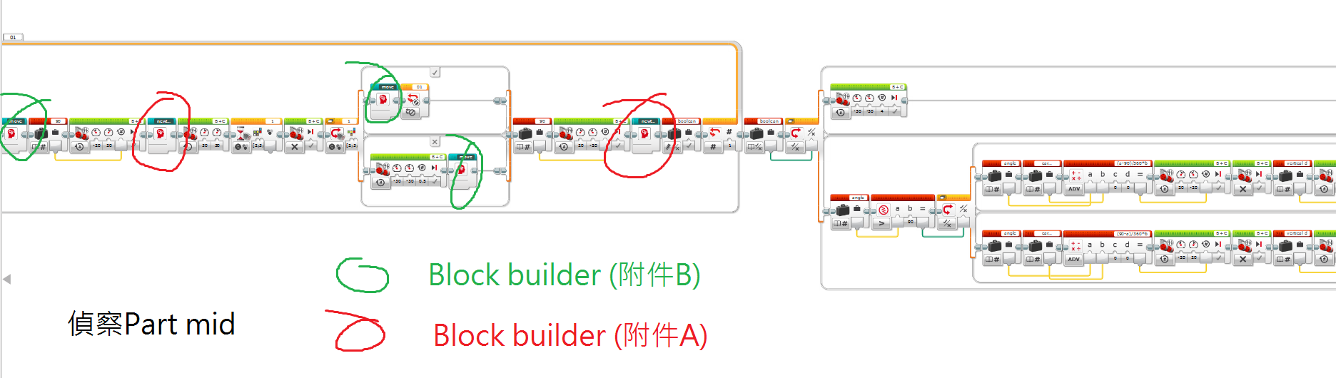

**Right part of the whole program**

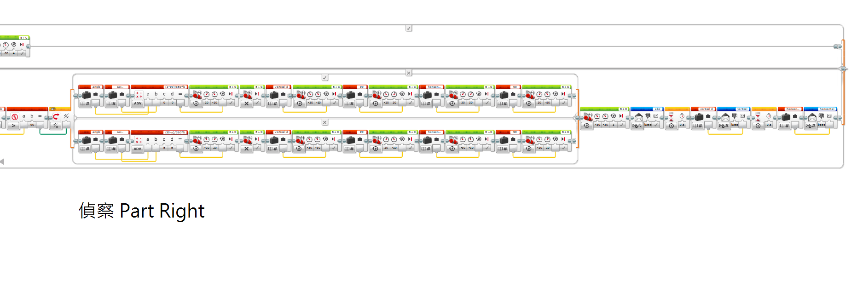

**Additional program of Prospector’s program**

**(The following program is the block builder which is circled in red and green on the above program)**

**Block builder A**

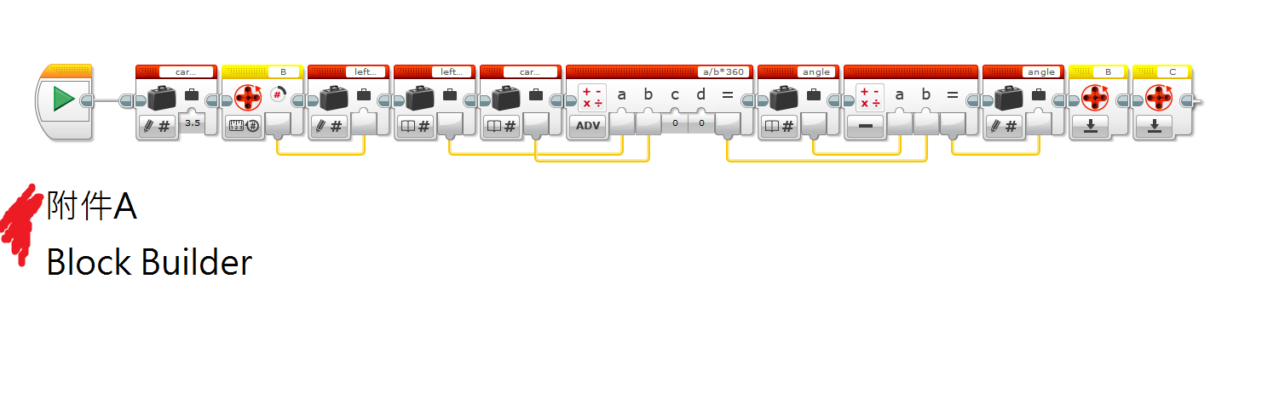

**Block builder B**

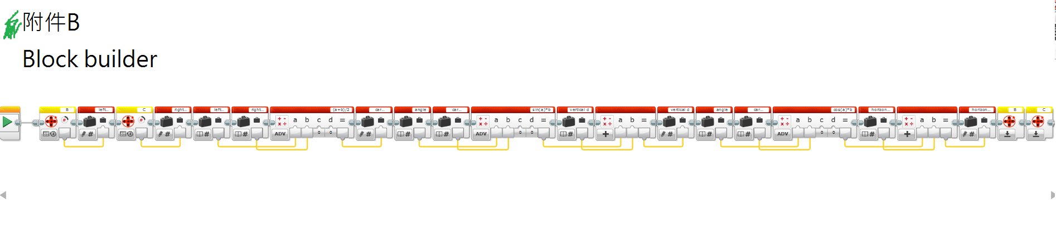

1. **Collector**

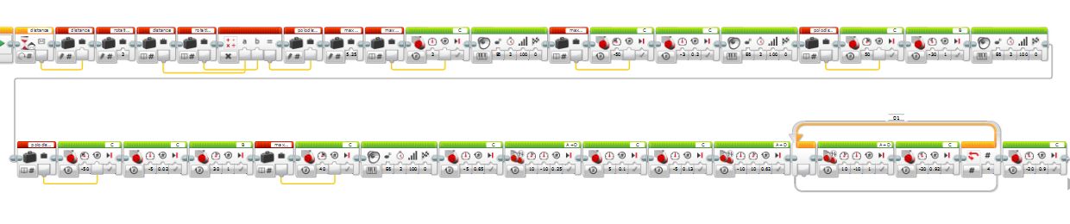

^ The above program is the whole program of collector

Program Interpretation: After the base receive the displacement data from the Prospector, it will calculate the size-different of tier of prospector and the tier of collector, and change the displacement value that according to the tier size of prospector to the displacement value of the tier size of collector, the valve save as polodistant. After the base adjust the initial angle of the departure of the collector. Furthermore, it will send the polodistant to the collector and collector will run the program. Putting down the railway and run on the railway, after that , collect the energy source. Finally , it will recycle the railway back that have been put down, and back to the base.